SK.SHAFI

1) write a java progarm to implement the concept bike HAS_A engine using aggregation?

class Engine
{
int engModel;
int engId;
String engName;
Engine(int a,int b,String c)
{
engModel=a;
engId=b;
engName=c;
}
}

class Yamaha
{
int Model;
int RegNumber;
Engine eng;
void setData(int x,int y, Engine z)
{
Model=x;
RegNumber=y;
eng=z;
}

void getData()
{
System.out.println("bike Model is"+ Model);
System.out.println("bike RegNumber is"+ RegNumber);
System.out.println("Engine details is"+ eng.engModel+" "+eng.engId+" "+eng.engName);
}
}

class Hasa
{
public static void main(String args[])
{
Engine e=new Engine(2014,67,"raju");

Yamaha y=new Yamaha();
y.setData(2321,231,e);
y.getData();
}
}
OUT PUT:
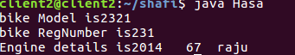

2)write a java to impliment compile time polymorphism ambugity accurence?

class Addition
{
void sum()
{
System.out.println("here no args to add");
}
int sum(int a,int b)
{
return a+b;
}
int sum(int a,int b,int c)
{
return a+b+c;
}

double sum(double a,double c)
{
return a+c;
}
}
class Poly
{
public static void main(String as[])
{
Addition a=new Addition();
int y=a.sum(10,20);
System.out.println("sum is"+y);
a.sum();
double d=a.sum(12.3,34.5);
System.out.println("sum is"+d);
a.sum();
}
}

OUT PUT:
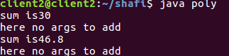

AMBUGITY:

class Ambugity
{
int sum(int a,int b)
{
System.out.println(a+b);
}
double sum(int a,int b){
System.out.println(a+b);
}

public static void main(String args[])
{
Ambugity obj=new Ambugity();
int result=obj.sum(30,20);
}
}

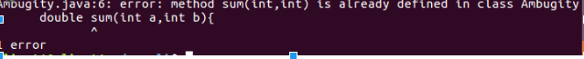

3) write a java progrm to impliment the following structure with paremeterizd constructor?
class A
{
A(int a)
{
System.out.println("a is"+a);
}
}
class B extends A
{
B(int a,int b)
{
super(a);
System.out.println("b is"+b);
}
}
class C extends B
{
C(int a,int b,int c)
{
super(a,b);
System.out.println("c is"+c);
}
}
class D extends A
{
D(int a,int b)
{
super(a);
System.out.println("b is"+b);
}
}
class E extends D
{
E(int a,int b,int c)
{
super(a,b);
System.out.println("c is"+c);
}
}

public class Parmerhe
{
public static void main(String args[])
{
C ob=new C(2,4,5);
E obj=new E(1,3,3);
}
}

OUT PUT:

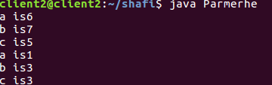

4) write a java program to check the behaviour of protected acess modifier in inheritance?

class Parent
{
protected int x;
protected double y;
void setData()
{
x=10;
y=23.5;
}
}
class child extends Parent
{
void getData()
{
System.out.println("x is"+x);
System.out.println("y is"+y);
}
}
class Acess
{
public static void main(String args[])
{
child p=new child();
p.setData();
p.getData();
}
}

OUT PUT:

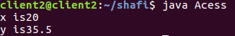

5.prepare a document for aggregration and identity difference inheritance and aggeregration

Aggregation :

Aggregation is a type of HAS-A relationship. Aggregation represents a type of relationship between two objects in which one contain the other’s reference. Two objects can exist independently. If one is deleted other can still exist.
Let us take the example: A room has a chair. Here room object contain the chair object. Both room and chair exist independed

identity | - identity: a variable holds the same instance as another variable.  - equality: two distinct objects can be used interchangeably. they often have the same id.

Difference between inheritance and aggregation

Inheritance: extend the functionality of a class by creating a subclass. Override superclass members in the subclasses to provide new functionality. Make methods abstract/virtual to force subclasses to "fill-in-the-blanks" when the superclass wants a particular interface but is agnostic about its implementation
Aggregation: create new functionality by taking other classes and combining them into a new class. Attach an common interface to this new class for interoperability with other code.

6.Prepare a document for compile time polymorphism
There are two types of polymorphism in java:
1.compile time polymorphism
2.runtime polymorphism.
1.Compile time polymorphism
It is also known as Static binding, Early binding and overloading as well. It is also known as Dynamic binding, Late binding and overriding as well. Overloading is compile time
}
class Employe
{// Employe deatials
Address add;
}

